Faculty of Science
Insert thesis title
20XX
Student Name
Master of Science in Environmental Sciences
Master's Thesis
Insert thesis title
Student Name · 20XX
Abstract
This abstract is a concise account of the research problem, methods, principal results, and main conclusion. Replace this text with an informative summary that can be understood independently of the remainder of the thesis.

Samenvatting
Voeg hier de Nederlandstalige samenvatting van het onderzoek toe. Beschrijf het probleem, de methode, de belangrijkste resultaten en de conclusie beknopt.

Acknowledgements
Use this optional page to acknowledge scientific, technical, institutional, and personal support received during the project.

 | CONTENT
2 | 1 | Introduction
2 | 1.1 | Research question
4 | 2 | Background
6 | 3 | Literature review
8 | 4 | Methodology
10 | 5 | Results
12 | 6 | Discussion
14 | 7 | Conclusion
15 |  | References
17 | A | Appendices

 | FIGURES
10 | Figure 1. Example figure demonstrating the caption and cross-reference styles.

 | TABLES
10 | Table 1. Example results table.

 | ACRONYMS
 | ECTS | European Credit Transfer and Accumulation System
 | OU | Open Universiteit
 | RQ | Research question

Foreword
Use this optional page for a brief personal introduction to the thesis, its origin, and the circumstances in which the work was completed.
INTRODUCTION

Introduction
The introduction establishes the scientific context, identifies the knowledge gap, and narrows the discussion towards a precise research question. It should also explain why answering that question matters.
Begin broadly enough to orient a reader from the same discipline, but make every paragraph contribute to the eventual research question. Define the scope and the principal assumptions explicitly.

Research question
State a focused question that can be answered with the data and methods available in the project. The answer to this question should form the central conclusion of the thesis.
A good research question is specific, answerable, and consequential.
BACKGROUND

Background
Introduce the topic in a way that is accessible to a reader who is not an expert in the precise subfield. Use references to support factual statements and to indicate the origin of ideas.
This chapter may also introduce the theoretical framework, define key concepts, and establish the notation used in subsequent chapters.
LITERATURE REVIEW

Literature review
A literature review surveys and synthesises published work relevant to the research question. It should compare approaches, identify limitations, and establish how the thesis contributes to the current state of knowledge.
Avoid presenting a sequence of disconnected summaries. Organise the discussion around themes, methods, or disagreements that lead naturally to the work undertaken in the thesis.
METHODOLOGY

Methodology
Describe the data, materials, models, and procedures in sufficient detail for a knowledgeable reader to evaluate and reproduce the analysis. Explain choices that materially affect the results.
State assumptions, preprocessing steps, uncertainty treatments, and ethical or data-management considerations where applicable.
Example code or pseudocode may be set using the OU Code style:
result = model.fit(data)
uncertainty = model.estimate_uncertainty()
RESULTS

Results
Present observations before interpreting them. Tables and figures should each communicate one principal point and remain understandable from their captions.
Use consistent units, notation, significant figures, and uncertainty reporting. Refer to every table and figure from the main text.
The presentation of figures and tables is illustrated in Figure 1 and Table 1. Update all fields with Ctrl+A followed by F9 in Microsoft Word.
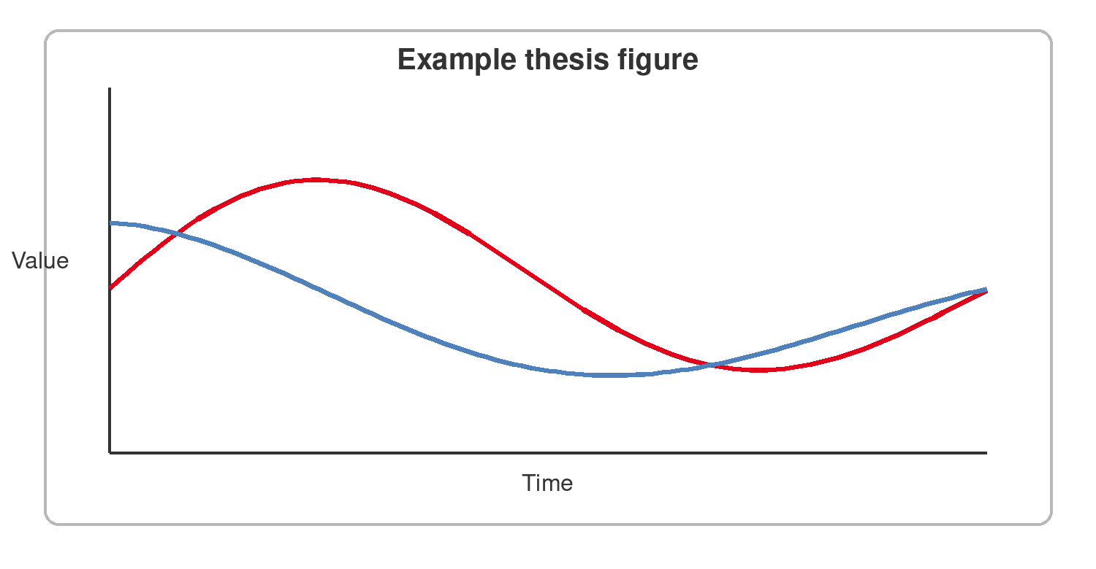
Figure 1. Example figure demonstrating the caption and cross-reference styles.
Table 1. Example results table.
Scenario | Mean | Uncertainty
Reference | 1.00 | ±0.05
Alternative A | 1.18 | ±0.06
Alternative B | 0.92 | ±0.04

DISCUSSION

Discussion
Relate the results to the research question and relevant literature. Distinguish robust conclusions from plausible interpretations and discuss uncertainty and limitations.
Explain the extent to which the conclusions can be generalised and identify the most useful directions for future work.
CONCLUSION

Conclusion
Answer the research question directly and briefly. Summarise the principal findings and their significance without introducing new data or new lines of argument.
A reader should be able to identify the contribution of the thesis and its main qualifications from this chapter alone.
Bibliography
Author, A. A. (Year). Title of the article. Journal Name, volume(issue), pages. https://doi.org/xx.xxxx/example
Author, B. B. (Year). Title of the book. Publisher.
APPENDICES
A

Appendices
Place supplementary derivations, questionnaires, additional figures, data descriptions, or other supporting material here.

Faculty of Science Open Universiteit
Valkenburgerweg 177, 6419 AT Heerlen ou.nl
Student Name Master of Science in Environmental Sciences

